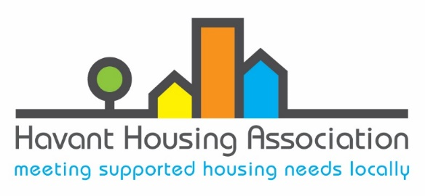
Easy Read Complaint Policy
What is a complaint?

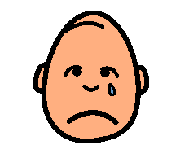
A complaint is when you feel unhappy about a service

This may happen because:

- We do something in the wrong way

- We don’t do something that should have been done

- We do something that should not have been done

Who can help me make a complaint?

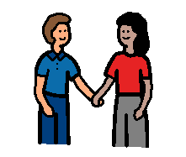
- A family member or friend

- A carer

- An advocate

What should I do if I am unhappy?

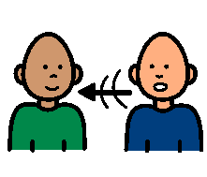 You can talk to us. Call 02392 643743

We can usually answer your questions and put things right for you quickly

How you can make a complaint

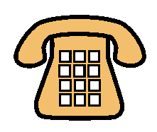02392 643 743 25 East Street, Havant, PO9 1AA
email: info@havantha.co.uk

What we will do

When you make a complaint we will:
Let you know we have received your complaint



We will contact you to talk about the problem. This person will be a Complaint Investigator

We will look into the problem

We will help you to understand what is happening at every stage.

If you are not happy with the response you can talk to the Ombudsman

Our promise to you

Ensure you are treated fairly and you receive appropriate support throughout the complaint


Make sure that if you have complained it will not affect how we support you in the future treatment

When mistakes happen, we will acknowledge them, apologise, explain what went wrong and put things right quickly

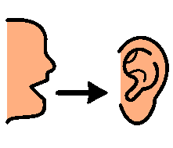
Ensure that we listen and learn from what you say if you complain about services.

